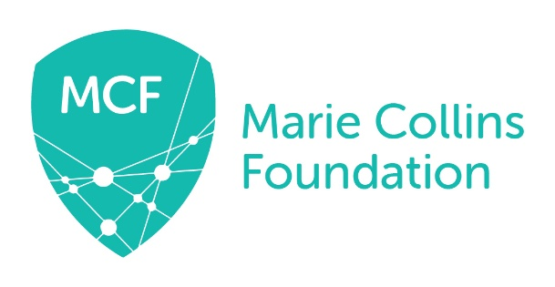

MARIE COLLINS FOUNDATION

Administrator - Job Description

Job Title: Administrator

Location: Home-based. The post holder will be required to work from Marie Collins Foundation’s Head Office in Northallerton, North Yorkshire on a regular basis. This post may also involve travel within the UK.

Reporting to: Director of Operations

Salary: £24,150 – 28,875 per annum (pro rata)

Working hours: This is a part-time position (0.6 FTE, 22.5 hours a week) and work will be carried out during normal office hours. However, the pattern of hours may vary according to operational needs and travel requirement where appropriate.

Contract: Permanent after probationary period (3 months). The post requires a satisfactory enhanced DBS check.

Annual Leave: 27 days per annum, pro rata, plus statutory holidays.

JOB FUNCTION:

To provide administrative support to MCF staff, Trustee Board and Lived Experience Group. The role will involve responsibility for specific areas as detailed below.

The Administrator will:

General administration:
- Respond to telephone and email enquiries, producing professional communications.
- Support the high-quality production of materials by proofreading for the team.
- Assist Director of Operations (DOO) with management of office premises, IT equipment and stationery.
- Oversee housekeeping of online filing system.
- Be cyber security aware and support DOO in implementing safe practices.

MCF Policies
- Manage the MCF policy review schedule.
- With CEO/DOO, develop new policies as required.
- Co-ordinate the review of existing policies.
- Co-ordinate the approval and launch of policies by CEO and Trustee board.

Risk Management
- Oversee the risk management function for MCF.
- With the Risk Management Group (RMG) Chair, co-ordinate the RMG meetings.
- Maintain and update the Risk Management Register.
- Coordinate MCF’s risk assessments and ensure SLT are aware if any need updating.
- Support MCF staff to complete, review and implement risk assessments.

Trustee Board
- Coordinate quarterly Trustee Board meetings and the AGM, record and distribute minutes.
- Produce agendas in discussion with the CEO and Chair.
- Coordinate trustee documents including the Code of Conduct, Declaration of Interest, Trustees’ Skills Audit, induction documents and DBS checks.
- Manage documents held within the Trustee Portal.

Staff Team
- Coordinate, schedule, and attend weekly and quarterly staff meetings; arrange accommodation and meeting venues as required.
- Support with the organisation of MCF’s annual conference, including travel and accommodation bookings for staff and guests.
- Maintain MCF’s Single Central Record and emergency contact information.
- Manage MCF’s DBS system, including checks for new staff and annual re-checks, using the Update Service, where possible.

Finance and Fundraising
- In the absence of DOO, process and code payments on the accounting software system, in line with annual financial budget.
- Monitor the funding landscape and support the CEO, DOO and wider team with funding applications.
- Ensure MCF meets the requirements of the Fundraising Code of Practice.

Service delivery
- Support with the co-ordination of the Lived Experience Group. This includes ensuring clear processes for HR and administration of meetings with appropriate agreements, Terms of Reference and Memorandums of Understanding.
- With the Training and Development Manager, ensure the coordination of both the UK and International training programmes. This includes ensuring clear processes are in place for bookings, payments, sending out course information and evaluations and help to develop resources.
- With the project leads, support the service delivery function of MCF, including the co-ordination of project meetings, minute taking and action plans and ensure that appropriate Memorandums of Understanding and/or Terms of Reference are in place.
- Carry out within reason, any other duties necessary for the smooth running of the organisation.

Acceptance Statement

- I have read and understood the role and responsibilities outlined above
- I will authorise MCF to undertake the appropriate check (enhanced) with the Disclosure & Barring Service (DBS).

Employee’s Signature Date _____________________

Chief Executive’s Signature Date _____________________
(For MCF)

